Getting Weird Results?

If you're getting weird results from your training process, make sure to reset runtime from the runtime menu as done in the videos. i.e:

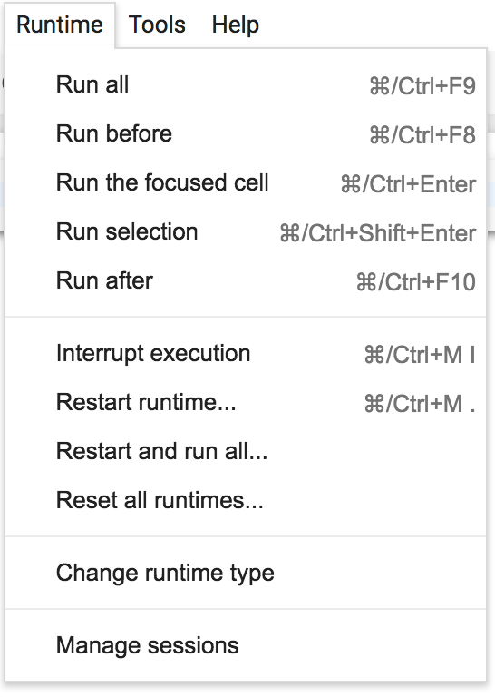

If you have any questions, feel free to ask me in the Q&A.

Best,

Rayan